Graphics terms
DEFINITIONS (C) AUSCLASSROOM.COM
anti-alias | To blur the edges of a bitmap object
bit depth | The number of bits of colour information available for each pixel. Bit depth is also referred to as colour depth or pixel depth.  An 8-bit image can contain up to 256 colours (2⁸=256)  A 24-bit image can contain up to 16,777,216 colours (2²⁴=16,777,216)
bitmap | An image consisting of pixels
bitmapped image | An image consisting of rows and columns of pixels. Also called raster file type. Example: frog.bmp - you can see the actual pixels that make up the eye if you zoom in:  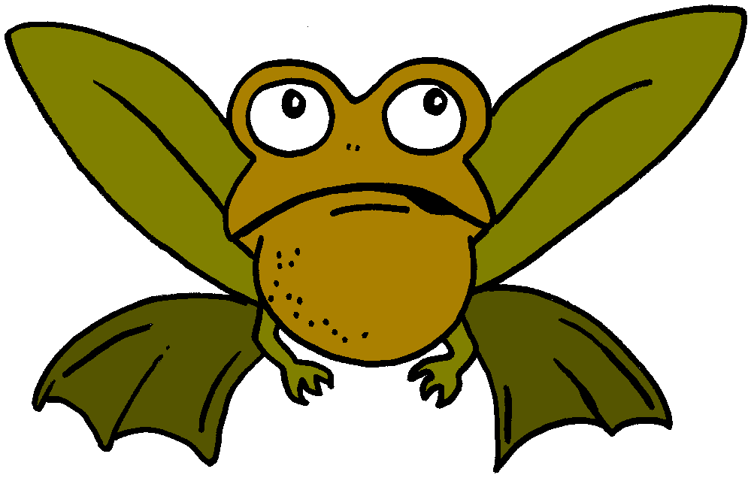➔  ➔ 
BMP | Windows bitmap format. A file format that can contain up to 24-bit colour images.
colour depth | bit depth
dots per inch | A measure of how sharp a printed image is. Pictures in Info are now 600 dpi. They used to be 300 dpi.
feather | To fade the edges of a an image
GIF | Graphical Interchange Format. A bitmap file that is limited to only 8-bit colour depth and uses lossless compression.
hue | The shade or tint of a colour
interpolation | Creating colour between pixels, based on surrounding colours.
JPG or JPEG | Joint Picture Experts Group. An image file type that allows up to 24-bit colour and uses lossy compression.
layer | A level of an image that can be edited separately from the rest of the image.
lossless compression | Reducing file size without any loss of image quality when the file is opened again.
lossy compression | Reducing file size by permanently losing some of the detail of an image.
luminance | The lightness of a colour
LZW compression | A way of reducing file size by grouping blocks of the same colour together.
opacity | The density of a colour. It ranges from transparent to completely opaque (solid).
palette | The collection of colours that are available for a particular image.
pixel | The smallest dot or tiny square of an image, monitor or printout.
raster | A bitmapped image.
resolution | How sharp an image, a monitor or printout is.  Smaller pixels mean better quality.  Image resolution is measured in ppi (pixels per inch), usually 72 ppi.  Monitor resolution is measured in dpi (dots per inch), usually about 96 dpi.  Printer resolution is measured in dpi (dots per inch), usually 300 or 600 dpi.
transparent GIF | A GIF file in which one of the 256 colours has been set to allow the background of a web page or document to show through.
vector | A file type in which the image is saved by converting its details into maths information such as lines, curves, arcs and polygons. Vector graphics is also called object-oriented graphics. Example: bird.wmf - the white of the eye is always the same maths shape:  ➔ ➔ ➔ ➔
WMF | Windows Metafile. A Windows file type that can contain both bitmapped and vector images. ("Meta" means "together".)

Graphics terms questions

Name: ............................................................ HG: .................... (C) AUSCLASSROOM.COM

These questions are based on the sheet called "Graphics terms - DEFINITIONS". Read it first.

1. Complete the table to compare GIF and JPG file types.
 | Full name  (the three-word term) | Colour depth  (8-bit or 24-bit) | Compression  (lossless or lossy)
GIF
JPG

2. Pixels and bit depth
What is a pixel?
What is bit depth?
How many colours are available in: |  | 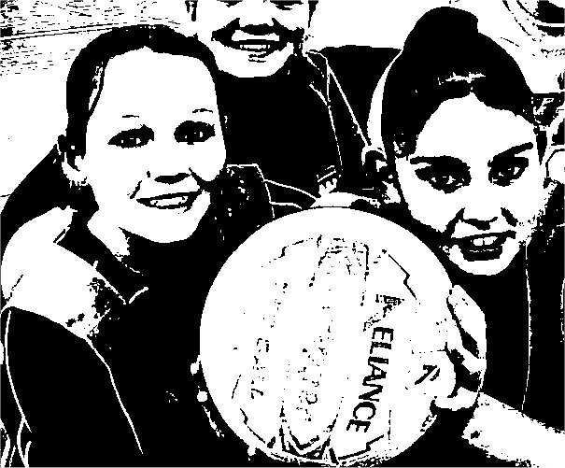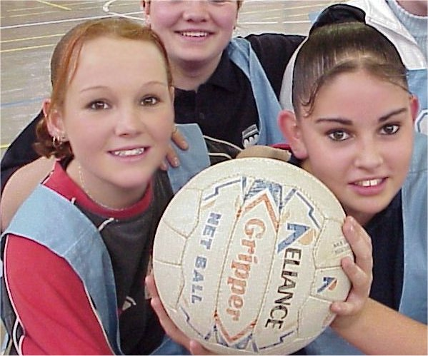  1-bit colour depth 24-bit colour depth
- an 8-bit image
- a 24-bit image
How many colours are available in:
- a BMP file
- a GIF file
- a JPG file
- a transparent GIF

3. Resolution
What is resolution?
For better quality do you need smaller or larger pixels?
How do we measure: |  | Remember, to find the information to answer these questions with, you need to read the Graphics Terms  DEFINITIONS  sheet
- image resolution
- monitor resolution
- printer resolution
What is the usual resolution of:
- images
- monitors
- printers

4. Compression
'Compression' means to squash something so as to reduce its size. Explain the difference between these two types of file compression:
Lossless
Lossy

5. Vector and raster graphics
Vector graphics and raster graphics are two different ways of holding information about a picture. Explain what the image details consist of:
Vector graphics
Raster graphics (also known as a bitmapped images)

What is a Windows Metafile?

6. Colour change terms
Give the term for each of the following.
The density of a colour
The lightness of a colour
The shade of a colour
The collection of colours that are available
A level that can be edited separately from the rest of an image
To fade the edges of an image
To blur the edges of a bitmap image

7. Explain these two main image file types in your own words:
GIF
JPG

8. Tick the most likely file type (each of the four file types is used only once):
a | b | c 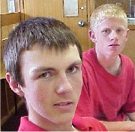 | d 
[ ] bmp [ ] gif  [ ] jpg [ ]wmf | [ ] bmp [ ] gif  [ ] jpg [ ]wmf | [ ] bmp [ ] gif  [ ] jpg [ ]wmf | [ ] bmp [ ] gif  [ ] jpg [ ]wmf

9. Crossword - Graphics Terms A
ACROSS
3. How dense a colour is.
5. How light a colour is.
7. A word describing a bitmap image.
9. The set of colours that can be used in a particular image.
10. An image consisting of pixels, as distinct from a vector image.
11. The number of bits of colour information available for each pixel (TWO WORDS).

DOWN
1. Bit depth (TWO WORDS).
2. A level of an image that can be edited separately from the rest of the image.
4. To soften the edge of a bitmap image
6. To fade the edges of an image.
8. A Windows bitmap format file.
12. The tint of a colour.

10. Crossword - Graphics Terms B
ACROSS
5. The sharpness of an image.
6. Reduced file size without loss of image quality.
7. Colour depth (TWO WORDS).
8. An image file with 24-bit colour depth.
9. Saved by converting details into maths objects such as lines and polygons.
12. Reducing file size by squashing information.

DOWN
1. PPI (THREE WORDS)
2. Kind of GIF where one colour lets the background show through.
3. DPI (THREE WORDS)
4. Reduced file size with permanent loss of image quality
10. Windows metafile.
11. A bitmap file with 8-bit colour depth.

11. Graphics Word Search
